**2*CREATE A TABLE EMPG WITH ATTRIBUTES EID PRIMARY KEY ,ENAME, AGE, SALARY:**

SQL> CREATE TABLE EMPG(EID NUMBER (20) PRIMARY KEY,ENAME VARCHAR(20),AGE NUMBER(20),SALARY NUMBER(20));

TABLE CREATED

**SQL> INSERT INTO EMPG VALUES(&EID,'&ENAME',&AGE,&SALARY);**

Enter value for eid: 1

Enter value for ename: GAYTAHRI

Enter value for age: 20

Enter value for salary: 50000

old 1: INSERT INTO EMPG VALUES(&EID,'&ENAME',&AGE,&SALARY)

new 1: INSERT INTO EMPG VALUES(1,'GAYTAHRI',20,50000)

1 row created.

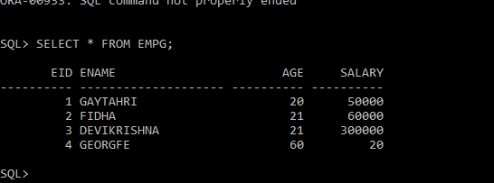

**\*COUNT OF EMPLOYEES**

SQL> SELECT COUNT (EID) FROM EMPG;

**COUNT (EID)**

**----------**

**4**

**\*FIND MAXIMUM AGE**

SQL> SELECT MAX (AGE) FROM EMPG;

**MAX (AGE)**

**----------**

**60**

**FIND MINIMUM AGE**

SQL> SELECT MIN (AGE) FROM EMPG;

**MIN (AGE)**

**----------**

**20**

**SQL>**

**\*SUM OF SALARY**

SQL> SELECT SUM (SALARY) FROM EMPG;

SUM (SALARY)

-----------

410020

SQL>

\***FIND AVG SALARY**

SQL> SELECT AVG (SALARY) FROM EMPG;

AVG (SALARY)

-----------

102505

* **FIND AVG AGE**

SQL> SELECT AVG(AGE) FROM EMPG;

AVG(AGE)

----------

30.5

SQL>

**3**\***CREATE VIEW FOR NAME AND AGE**

**SQL> CREATE OR REPLACE VIEW AGEVIEW AS SELECT ENAME,AGE FROM EMPG WHERE AGE >30;**

View created.

SQL>

**DISPLAY THE NAME OF EMPLOYEE IN THE DECENDING ORDER OF SALARY**

SQL> SELECT ENAME SALARY FROM EMPG ORDER BY SALARY DESC;

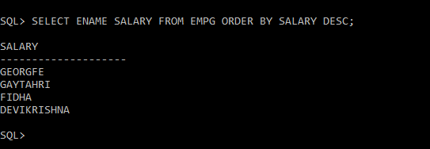

**DISPLAY AGE ASENDING ORDER**

SQL> SELECT ENAME AGE FROM EMPG ORDER BY AGE;

AGE

--------------------

DEVIKRISHNA

FIDHA

GAYTAHRI

GEORGE

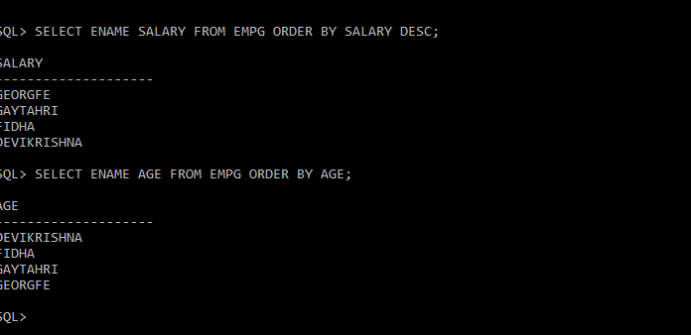

**4. foreign key**

**Create the following table sailors,sid,sname,rating,age**

SQL> CREATE TABLE SAILORS(SID NUMBER(20)PRIMARY KEY,SNAME VARCHAR(20),RATING NUMBER(20) ,AGE NUMBER(10));

Table created.

**\*Boats bid foreign key,bname,color**

SQL> CREATE TABLE BOAT(BID NUMBER(20) PRIMARY KEY,BNAME VARCHAR(20),COLOR VARCHAR(20));

Table created.

**\*CREATE TABLE RESERVERS REFERENCES FROM SAILORS AND BOAT**

CREATE TABLE RESERVES(SID NUMBER REFERENCES SAILORS(SID),BID NUMBER REFERENCES BOAT(BID),DAY DATE);

Table created.

INSERT INTO SAILORS VALUES(&SID ,'&SNAME',&RATING,&AGE);

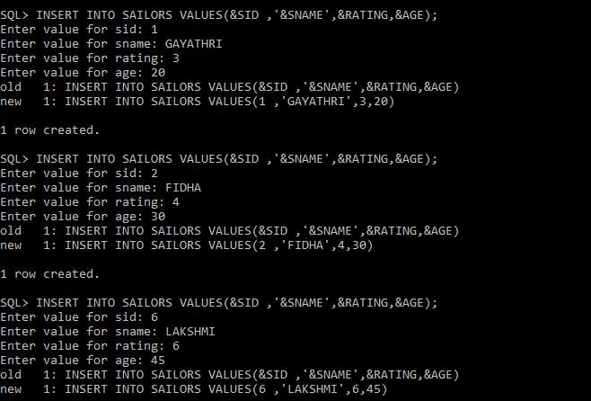



**SQL> SELECT * FROM SAILORS;**

SID SNAME RATING AGE

---------- -------------------- ---------- ----------

1 GAYATHRI 3 20

2 FIDHA 4 30

6 LAKSHMI 6 45

SQL>

INSERT VALUES IN BOAT

SQL> INSERT INTO BOAT VALUES(&BID,'&BNAME','&COLOR');

Enter value for bid: 1

Enter value for bname: RIO

Enter value for color: RED

old 1: INSERT INTO BOAT VALUES(&BID,'&BNAME','&COLOR')

new 1: INSERT INTO BOAT VALUES(1,'RIO','RED')

1 row created.

SQL> INSERT INTO BOAT VALUES(&BID,'&BNAME','&COLOR');

Enter value for bid: 2

Enter value for bname: RAONE

Enter value for color: BLUE

old 1: INSERT INTO BOAT VALUES(&BID,'&BNAME','&COLOR')

new 1: INSERT INTO BOAT VALUES(2,'RAONE','BLUE')

1 row created.

SQL> INSERT INTO BOAT VALUES(&BID,'&BNAME','&COLOR');

Enter value for bid: 3

Enter value for bname: OCEAN

Enter value for color: ROSE

old 1: INSERT INTO BOAT VALUES(&BID,'&BNAME','&COLOR')

new 1: INSERT INTO BOAT VALUES(3,'OCEAN','ROSE')

1 row created.

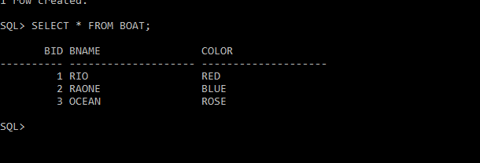

SQL> SELECT * FROM BOAT;

BID BNAME COLOR

---------- -------------------- --------------------

1 RIO RED

2 RAONE BLUE

3 OCEAN ROSE

SQL> SELECT SNAME ,AGE FROM SAILORS;

SNAME AGE

-------------------- ----------

GAYATHRI 20

FIDHA 30

LAKSHMI 45

SQL>

